Lab 3

1. 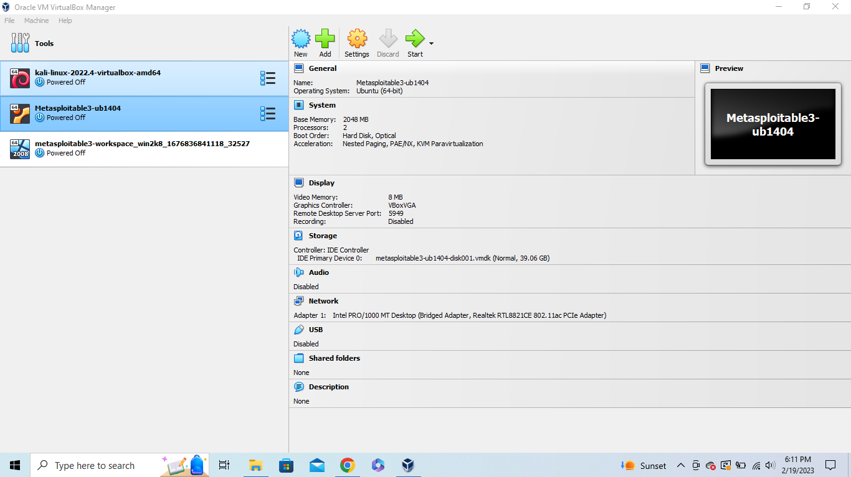Virtual Box
2. Ping session from Kali to the Windows Metasploitable Install

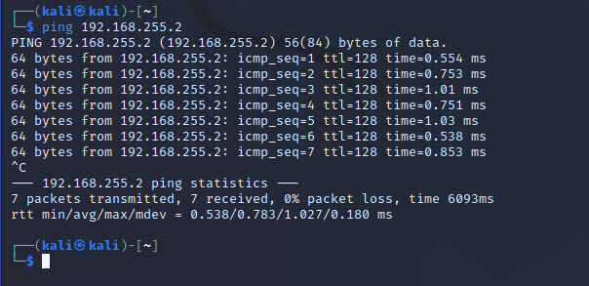

1. Ping session from Kali to the Linux Metasploitable install

